# Compare Index Performance Against Benchmark

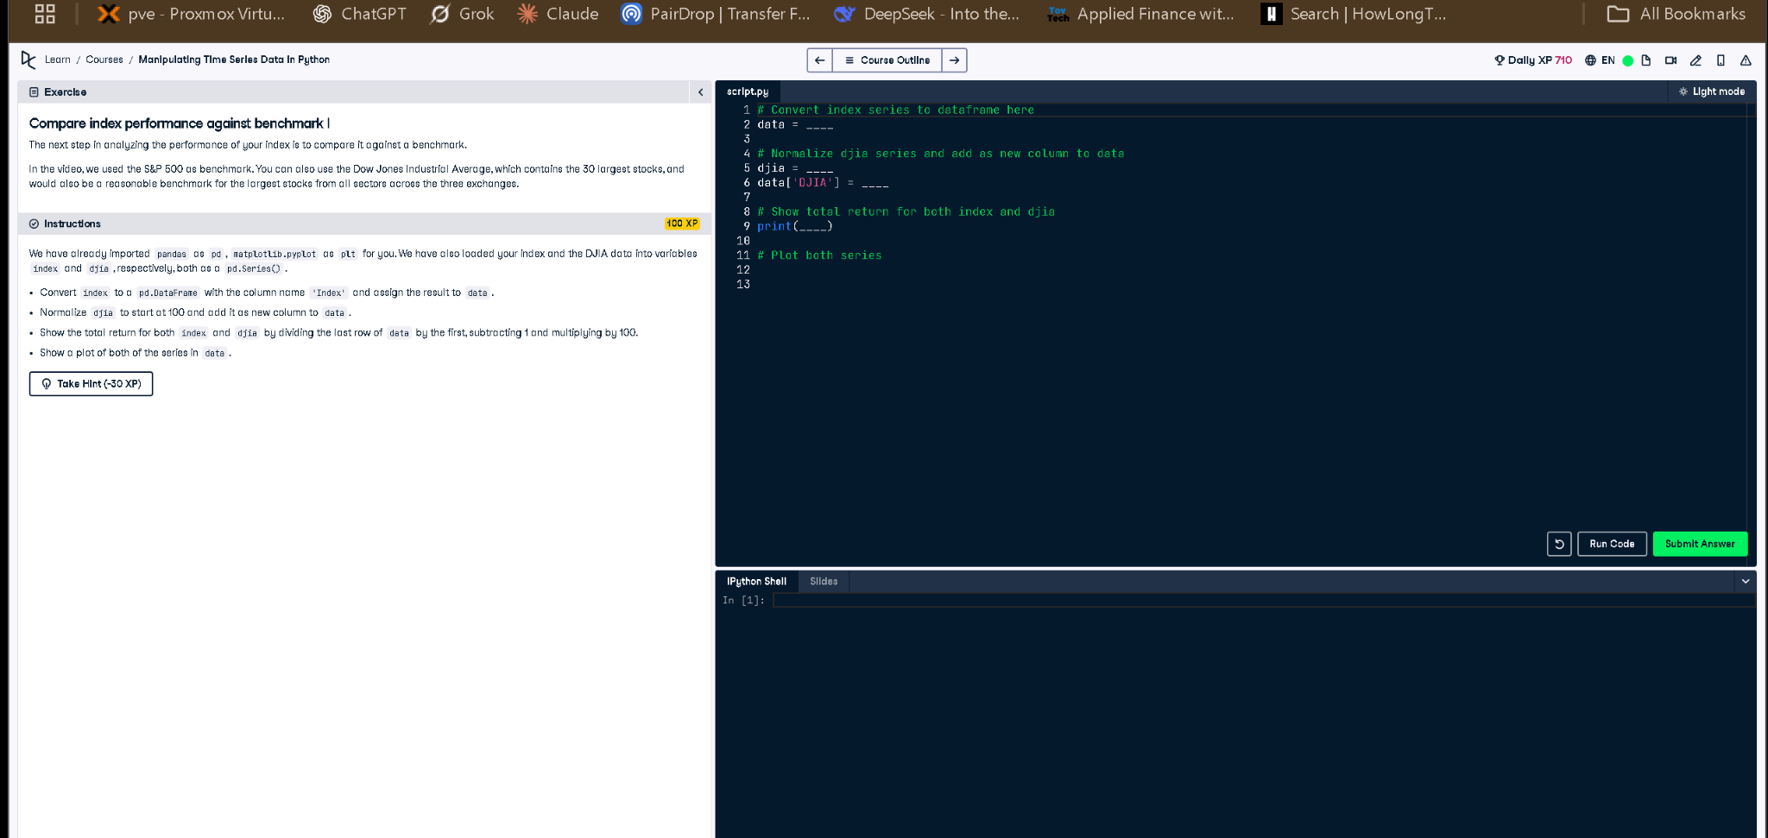

Figure: Screenshot of the exercise and code editor

## Correct Python Code

# Convert index series to dataframe here  
data = index.to_frame(name='Index')  
  
# Normalize djia series and add as new column to data  
djia = djia / djia.iloc[0] * 100  
data['DJIA'] = djia  
  
# Show total return for both index and djia  
print((data.iloc[-1] / data.iloc[0] - 1) * 100)  
  
# Plot both series  
data.plot(title='Index vs DJIA')

## Explanation

This task compares your custom index to the DJIA benchmark. First, it converts the index into a DataFrame. Then it normalizes DJIA to start at 100 for comparison. The total return of both is calculated by comparing the last and first values. Finally, both are plotted to visualize performance.